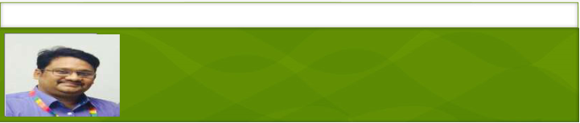
sudheerrao@rediffmail.com +919848197988
SUDHEER JALIGAMA
SENIOR LEVEL PROFESSIONAL- Over 19 years of experience
Retail Sales & Service Operations | Channel Management | Business Development

Profile Summary
A strategic planner with recognized proficiency in managing sales and marketing activities with an aim to accomplish set plans & targets. Expertise in proactively identifying & resolving problems, reversing negative trend, controlling costs, and maximizing profits. Comprehensive experience in leading dedicated teams for running successful business operations and developing procedures & service standards for business excellence. Experience in managing & executing various promotional activities / events and escalating business, profitability and market coverage.
Skilled in developing & managing retail channels in order to derive the required market share, revenue and profit of the organization. Excellent interpersonal, analytical & negotiation skills with proven track record of spearheading cost innovation projects during the career span. Possess in-depth knowledge in designing entire product range including brand, category and product mix. Proficient at providing value added customer service by resolving customer issues & ensuring their satisfaction with the product and the service norms.

Education
- Post Graduate Diploma in Management (Retail) from Prin. L. N. Welingkar Institute of Management Development & Research, Mumbai in 2016.
- MBA (IT) Bharati Vidyapeeth Deemed University, Pune in 2001 with 65.11%
- B.Com. from Kakatiya University, Warangal in 1999 with 63.75%

Areas of Expertise | Soft Skills | Achievements
Footfall Management  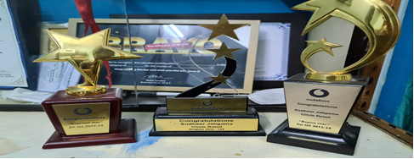’  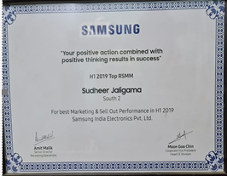 | Change Agent  Motivational Leader  Strategic Thinker  Collaborator  Communicator  Innovator.  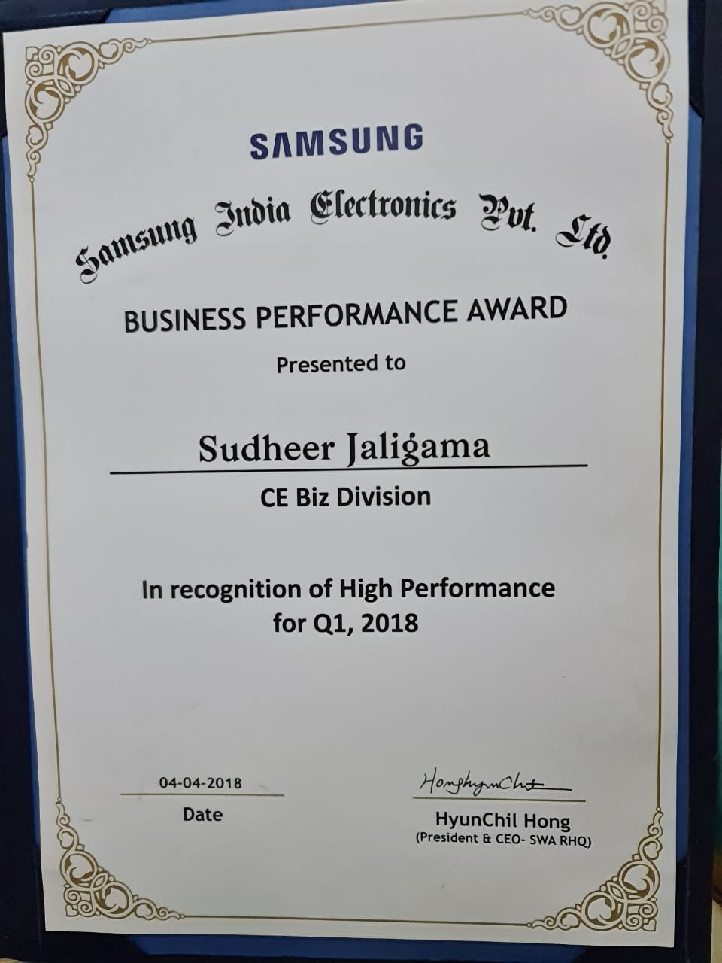    “TOP GUN Award” – Q1 2021 Samsung for business growth  My Awards  “Go Smart Award – Mktg Operations-2020”- Samsung.  “Won QBR-Award” for Q1-2018.  At Samsung for growth  “Region Star Award" for Q1 & Q2 , Q3  At Vodafone  "Super Star Award" for the Month of Aug’12  “Super Star Award" for the Month of Nov’13  “FIFA Asia Awards” for "Best Display" category, Future Group
  Strategic Planning
  Store Deployment
  Channel & Distribution Management
  P&L Management/ Cost Benefit Analysis
  People Management
  Business Development

Career Timeline
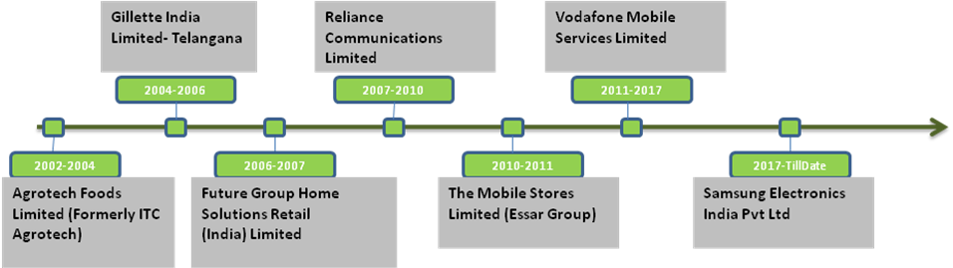
Work Experience
Samsung Electronics India Pvt Ltd- Regional Manager Sell Out & Marketing (7th April 2017 to till date)

Deputy General Manager
- Regional Drive for Sellout in all the formats of South 2 ( AP &Telangana)-560 Out lets
- Improving Manpower quality by Training and ensuring higher Productivity of Samsung Expert Consultants -1300 SEC
- Formulating & implementing business plan for the region for target & goal setting, merchandising planning, marketing budget and end to end responsible for branding across the General Trade.
- Contributing to planning and execution of Training across the Region
- Cross Functional Coordination in tune with process compliance.
- Achieving the Turnover targets for the region through sell out, competition tracking, High Counter Share, Display share of the Brand in all categories across the Out lets.

Key Objectives

- Strengthen profit-based upselling of premium products by optimizing SKU (Stock Keeping Unit) for each store.
- Minimize faulty products and obsolete inventory through store's inventory management.

Key Tasks

- Project Management: -Manage the progress and performance of collaborative tasks for retailers, subsidiaries and HQ by phase.
- Retailer engagement Understand the pain points of the retailers by analysing store sales data and plan countermeasures to drive collaboration with retailers.
- Retail mapping Check to identify the retailers having the highest growth potential to achieve the maximum return on investment.
- SKU (Stock Keeping Unit) optimization Optimize SKU (Stock Keeping Unit) by premium, setup and mass product by using retail mapping and considering store sales characteristics.
- Store inventory management (stockout, obsolete inventory management)] Optimize SKU (Stock Keeping Unit) by premium and mass product with retailers by using retail mapping and considering store sales characteristics to differentiate premium/setup/entry products

Since Jan'13
Vodafone Mobile Services Limited- Retail Operations & Customer Experience (A.P.& T)
Growth Path:
Jan'13-Mar'16: Deputy Manager
Mar'16-May'16: Senior Manager (Internal Designation Framework Change)
Jun'16 to till date: Assistant General Manager
Key Result Areas:
Assistant General Manager
- In-charge for store operations of 42 COCO (VS) and 230 FOFO(VMS) stores, along with managing 830 associate distributors (ADVMS); balancing quality, cost and revenue objectives, increasing employee satisfaction, improving service quality and ensuring higher customer loyalty
- Formulating & implementing business plan for the region for target & goal setting, merchandising planning, marketing budget, P&L accountability, KPIs, new business development and so on
- Contributing in planning and execution of strategies related to quality acquisition & complaint management
- Increasing retail productivity and operational efficiencies by right person at right store.
- Leading innovation and optimization across channels to continuously enhance company offerings and customer experiences
- Rolling out Annual Business Plan for the business partners and aligning it with the company’s objectives; monitoring the timely launch & availability of new products across all retail counters
- Coordinating with multiple stakeholders for timely training deployment, service quality compliance, manpower management

Deputy Manager
- Initiated market development efforts and increased business growth to make Vodafone a dominant brand in Modern Trade space; managed an overall base revenues of INR 1.2 Crores per month and incremental revenues of INR 25 Lakhs per month
- Explored potential business avenues in the Telecom category of Modern Trade Accounts in Andhra Pradesh and managed marketing & sales operations for achieving the business targets; managed National and Regional Modern Trade partners
- Analyzed latest marketing trends, tracked competitors' activities and provided valuable inputs for fine-tuning sales & marketing strategies
- Defined channel marketing strategy, including development of channel partners in accordance with the overall business goals and objectives
- Managed CDEIT LFRs such as Reliance Digital and Croma, Bajaj & TMS Regional Accounts: Univercell, Sangeeta, and Big C
- Administered various other activities related to the Terms of Trade (TOT) Management; worked towards improving the quality of acquisition
Significant Achievements:
- Launched 13 COCO Stores and 100 FOFO Stores in 12 months.
- Managed overall retail operations and business continuity plan, ensuring adherence to audit and compliance processes, policies, and procedures; attained quality scores of ADVMS & VMS at 82 % and COCO Stores at 90% Scores, which were the highest scores received ever
- Winner of the
- "Region Star Award" for Q1 & Q2 , Q3 respectively in the FY2014 - 2015
- "Super Star Award" for the Month of Aug’12 & Nov’13
- Propelled the turnaround of Secunderabad Store, transforming it to be the no. 1 in customer satisfaction and win "TTrain Award for the South" for outstanding customer experience
- Led AP region store to be recognized as the No. 2 on National Level and No. 1 in the South India region for Usage Drive at the CIBIL Contest 2013
- Acted as core member of the "Redbuild" and played a major role in the design and implementation of the process
- Reversed 30 store’s downward spiral by overhauling systems, processes, training programs and personnel; corrected issues such as internal theft, lagging customer service and poor morale
- Recognized for attaining the Best Acquisition Churn Rate in the country for postpaid accounts
- Appeared as the No.1 store in the GH Shop Score at NPS, Aug'2013
- Pivotal in opening 3Angel Stores on Diversity Drive

Sep’10–Apr'11
The Mobile Stores Limited (Essar Group), Cluster Head – ROAP
Formulated & implemented a highly collaborative comprehensive strategy for sale of Mobile Handsets across XROAP region areas and throughout the product lifecycle; managed monthly business volumes worth INR 3 Crore, with 5500 ASP of value INR 36 Crore per annum. Administered various other responsibilities related to Inventory Management, Supply Chain Management, Marketing, Recruitment of new team members and Strategic Planning.
Significant Achievements:
- Managed business of 54 stores in the region; led a team of 4 Area Operations Managers, 1 Marketing Manager, 100 Store Executives and 4Operations Managers, and reported to the National Head - Retail
- Increased the sales growth from 12% to 40% in value for FY 2011within the assigned geographical zone of ROAP which was the best/ highest in the country
- Formulated and executed go-to-market strategies that leveraged tremendous opportunities in terms of growth in revenue from 17% to 19% for Smartphone in the cluster
- Recognized as the first manager to achieve the highest ever mark of 18000 Prepaid Acquisitions month-on-month
- Enhanced the partner business readiness process through the formation and leadership of a virtual team that developed business requirements, coordinated system testing, and designed and delivered partner training
- Steered the design, development and implementation of marketing strategies & elements like VM, In-shop, Store Level BTL, and Handset Model or Catchment Specific Activities, in coordination with the Regional and National Handset Sales & Operator Business Teams
Aug’07-Sep’10
Reliance Communications, Andhra Pradesh
Growth Path
Aug’07-Nov’09: Area Sales Manager
Dec’09–Sep’10: Operations Lead– Retail
Managed overall retail operations, business continuity plan and BPMS execution for the cluster, ensuring adherence to audit and compliance processes, policies, and procedures. Led upkeep of the store to provide the requisite ambience to the customers.Created periodic financial & sales reports to identify trends and ensured stores are on the correct growth curve; developed sales department budget, determined appropriate staffing levels and identified Store Operating Expenditure (OPEX).

Significant Achievements:
- Increased net profit by 30% through the channel and attained 100% higher margin in the FY’20007-08 as compared to FY’2006-07
- Spearheaded the ‘Store Team’ in the RW’s, including 30Store Manager, 30 Team Leaders &150Customer Care Associates for rendering a high standard of customer experience through people management, training and career development of team
- Achieved 125% of the planned sales within 6 months in SEP and won 2 grams of Gold Coins
- Assisted4store manager in driving Revenuesto achieve #5 Pan India rank for the staff engagement program, for (SEP) Q3 of FY 2007
- Attained Outstanding audit report ratings for all stores across the cluster in the FY 2007
- Played a key role in planning and implementation of “National Digital Elocution Competition -2007” in AP region, which led to an overall contribution of over 3000 registrations to national achievement of 10,000 registrations
- Spearheaded major projects of EBay and Big Flicks
- Pivotal in BPMS execution; ensured compliance of ‘Processes’ by the team members including filling up of all requisite trackers at the stores through regular ‘Process Audits’
- Ensured smooth execution of sales promotion campaign display/ merchandising plan in the stores, new product launches & events with MSM / BBC Leads; planned the calendar and execution of various programs for various retail chains as per budget
- Managed business of postpaid, prepaid & broadband sales through30 Company-Owned Company Operated (COCO) stores; planned and executed complete Reliance brand shop initiatives for retail partner
- Planned, organized & executed plans to implement customer care metrics, processes and plans in coordination with RIC to maximize the CSI points
- Prepared monthly scheme proposals and promotional activities such as Spot-Sales, Brand Promotions, Display Offers and so on, with MSM / BBC Leads

Feb’06–Aug’07
Future Group Home Solutions Retail (India) Limited, A.P. as Deputy Manager-Operations
Worked within Future Group Home Solutions Retail (India) Limited with the Lifestyle Division of their e-zone store based in Andhra Pradesh. Coordinated with the zonal manager to determine cost control, inventory requirements and forecast sales figures for the store. Engaged in the business development, implementation and integration of new initiatives within the territory.
Significant Achievements:
- Led the start-up and grand opening of Ezone Store; exceeded sales and profit goals by 120%, respectively, in the second month of opening
- Implemented and followed up retail practices and standards in all Ezone stores across APstores
- Under the leadership, "Collection-I" & "E-Zone" won the FIFA Asia Awards for "Best Display" category
- Chalked out methods to determine the best methods of promoting products; developed and updated knowledge of own products and the products of their competitors; enhanced sales by 40%
- Conducted SWOT analysis and delivered market and competitor intelligence throughout the sales area; positioned sales teams with the knowledge to further differentiate offerings and increase IT, Panelsales
- Assisted in promoting sales of ITin stores and achieved maximum sales in the same category within a span of 3 months
Previous Experience

Jun’04–Feb’06 with Gillette India Limited, Andhra Pradesh as TSI-Hyderabad

Jul’01–Jun’04 with Agrotech Foods Limited (Formerly ITC Agrotech), Tirupathi
Growth Path
Jul’01–Jun’02: Promotions Consultant- ACT-II Brand
Jun'02-Jun’04: Sales Officer, Tirupathi

IT Skills
- Knowledge of MS Office and Internet Applications

Personal Details
Date of Birth: 23rdMarch 1979
Languages Known: English, Telugu, Hindi & Marathi
Address : H. No.: 2-4-275/103, Plot No. 103 Part, Road No. 5, Snehapuri Colony, R.K.Puram, Hyderabad-500035, A.P.

